Q.What is JavaScript. How to use it?

Ans : JavaScript is a scripting language used to create and control dynamic website content.There are 3 ways to use javascript, ( 1 ) JavaScript code between a pair of <script>... </script> tag ( 2 ) Inline Code ( 3 ) External file with .js extension.

Q. How many type of Variable in JavaScript?

Ans : there are three different variable types: var , let , and const .

Q. Define a Data Types in js?

Ans : Data types in JavaScript define the data type that a variable can store. JavaScript includes primitive and non-primitive data types.

Q. Write a mul Function Which will Work Properly When invoked With Following Syntax.

Ans :

function mul(x) {

return function (y) {

return function (z) {

return x * y * z;

};

};

}

Q. What the deference between undefined and undeclare in JavaScript?

Ans : Undefined occurs when a variable has been declared but has not been assigned any value, Where as Undeclared occurs when we try to access any variable that is not initialized or declared earlier using the var or const keyword.

Q. Using console.log() print out the following statement: The quote 'There is no exercise better for the heart than reaching down and lifting people up.' by John Holmes teaches us to help one another. Using console.log() print out the following quote by Mother Teresa:

Ans :

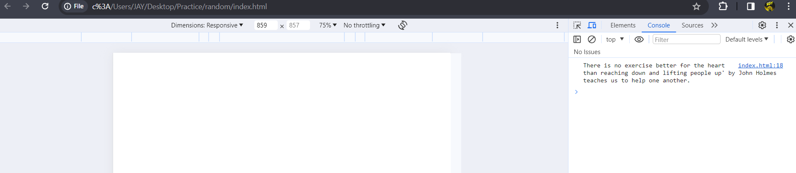

Q. Check if typeof '10' is exactly equal to 10. If not make it exactly equal?

Ans: In JavaScript, the typeof operator returns a string indicating the type of the operand. If you use typeof '10', it will return the string "string". To check if it's exactly equal to the number 10, you can convert the string to a number and then perform the comparison. Here's how you can do it:

In this case, the string "10" is changed to the number 10 by using parseInt(stringValue, 10). The next if statement determines whether the outcome is a number and whether it is precisely equal to 10. It updates the value to 10 if it is not.

Q. Write a JavaScript Program to find the area of a triangle?

Ans :

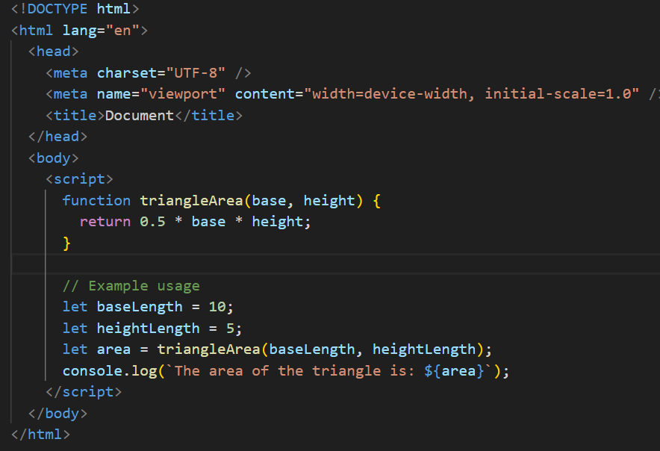 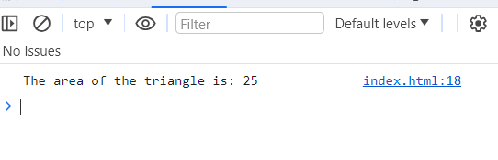

Q. Write a JavaScript program to calculate days left until next Christmas?

Ans :

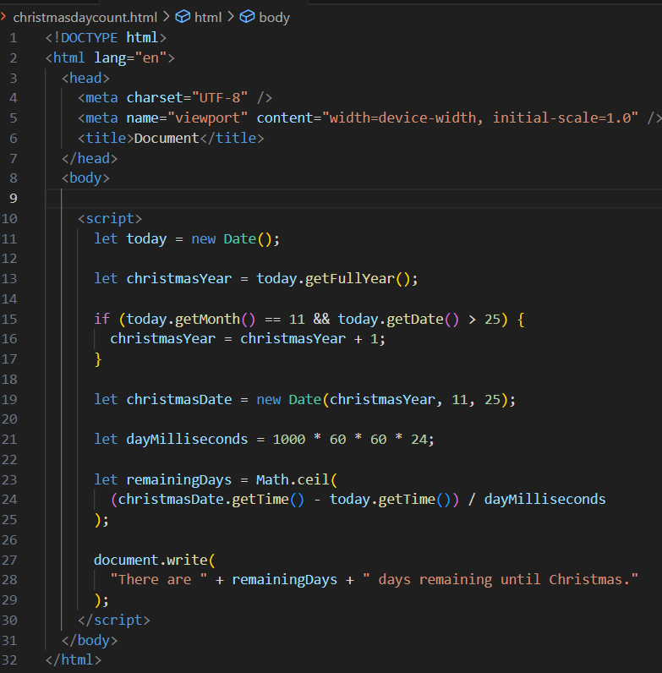

Q. What is Condition Statement?

Ans : Conditional statements in JavaScript allow you to execute specific blocks of code based on conditions. If the condition meets then a particular block of action will be executed otherwise it will execute another block of action that satisfies that particular condition.

Q. Find circumference of Rectangle formula : C = 4 * a ?

Ans : It appears that the formula you have given might include an error. Usually, the total of the four sides is used to determine a rectangle's circumference, or perimeter. The circumference (C) of a rectangle with sides of length a and b can be found using the following formula:

C=2a+2b

Q. WAP to convert years into days and days into years?

Ans :

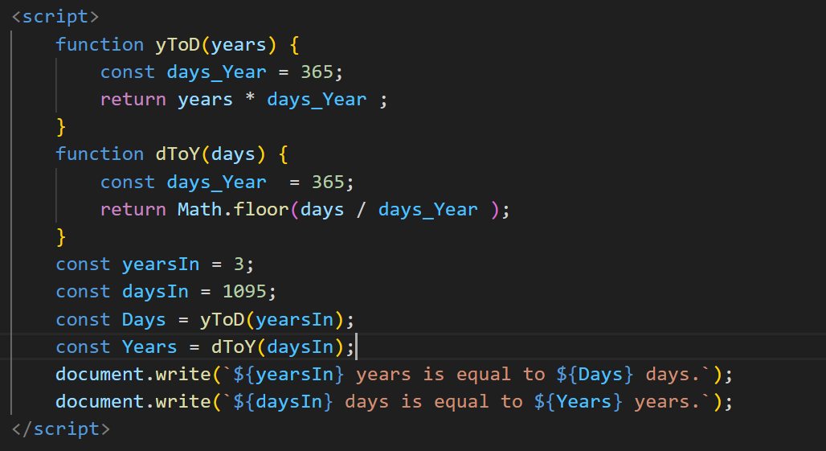

Q. Convert temperature Fahrenheit to Celsius? (Conditional logic Question)

Ans :

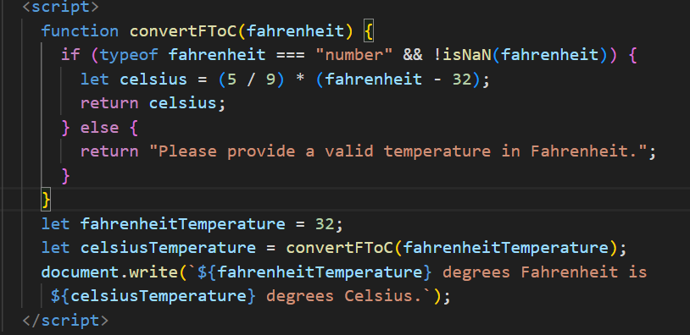

Q. Write a JavaScript exercise to get the extension of a filename.?

Ans :

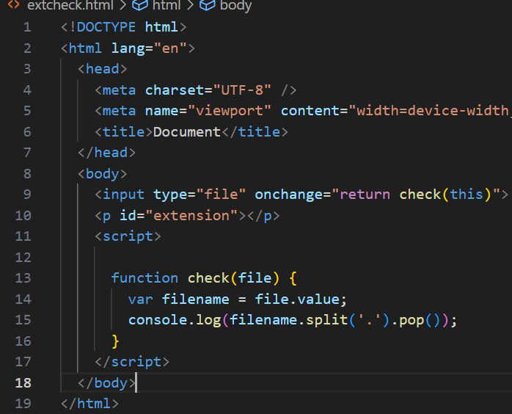

Q. What is the result of the expression (5 > 3 && 2 < 4)?

Ans : True.

Q. What is the result of the expression (true && 1 && "hello")?

Ans : Hello

Q. What is the result of the expression true && false || false && true?

Ans : False

Q. What is a Loop and Switch Case in JavaScript define that ?

Ans : A for loop is a control structure that allows you to repeat a block of code a certain number of times, while a switch case is a control structure that allows you to execute different blocks of code based on the value of an expression.

Q. What is the use of is Nan function?

Ans : The JavaScript isNaN() Function is used to check whether a given value is an illegal number or not. It returns true if the value is a NaN else returns false.

Q. What is the difference between && and || in JavaScript?

Ans : || means “or”. It evaluates to true if the expression on either side is truthy. && means “and”. It evaluates to false if the expression on either side is falsy. If the expression on the left of && is falsy, it will immediately return false without checking the expression on the right.

Q. What is the use of Void (0)?

Ans :  It is used to prevent any side effects caused while inserting an expression in a web page.

Q. Check Number Is Positive or Negative in JavaScript?

Ans : The Math.sign() method retuns whether a number is negative, positive or zero.

* If the number is positive, this method returns 1.
* If the number is negative, it returns -1.
* If the number is zero, it returns 0.

Q. Write to check whether a number is negative, positive or zero?

Ans :

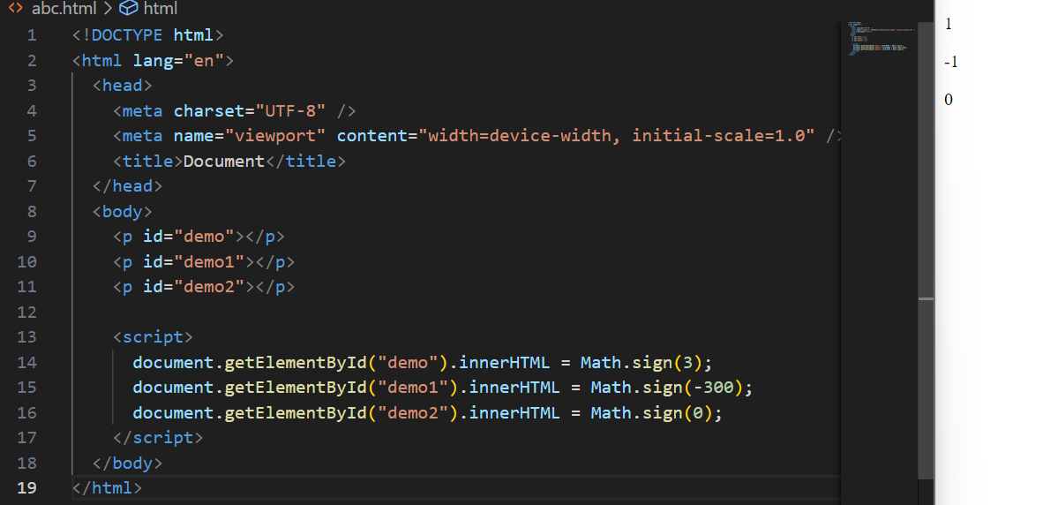

Q. Write to find number is even or odd using ternary operator in JS?

Ans :

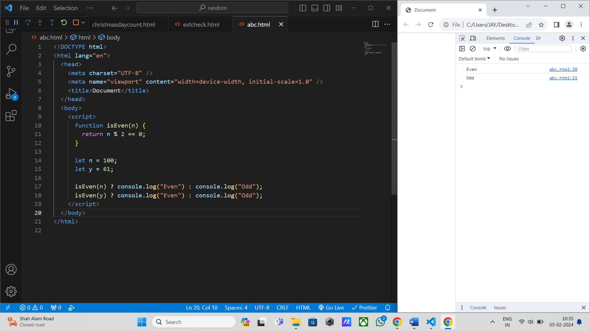

Q. Write to find maximum number among 3 numbers using ternary operator in JS?

Ans :

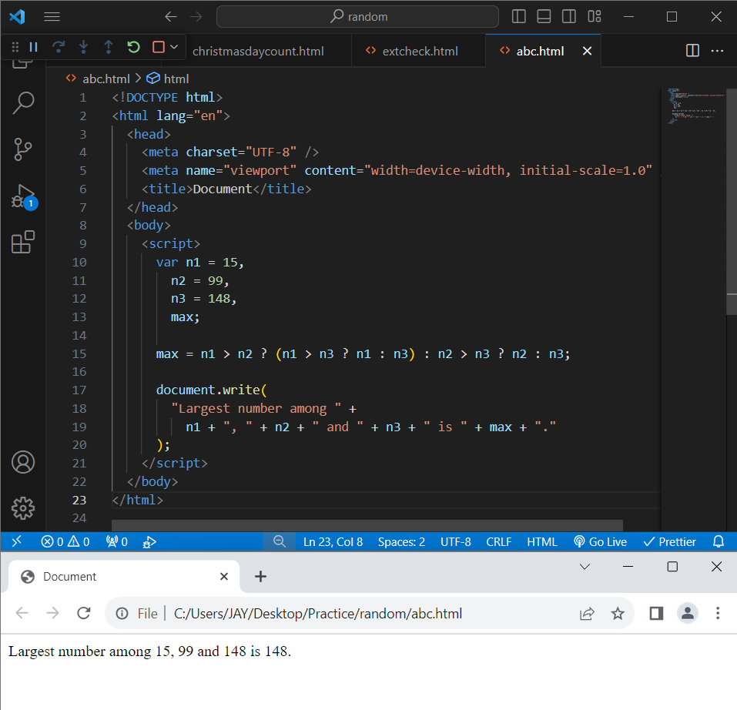

Q. Write to find minimum number among 3 numbers using ternary operator in JS?

Ans :

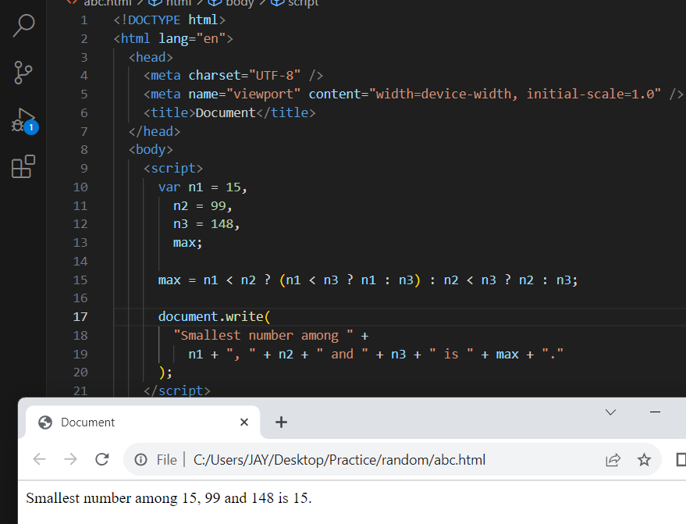

Q. Write to find the largest of three numbers in JS?

Ans :

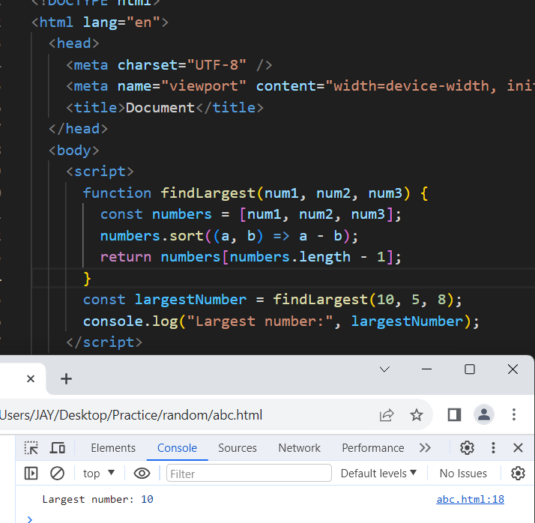

Q. Write to show

i. Monday to Sunday using switch case in JS?

Ans :

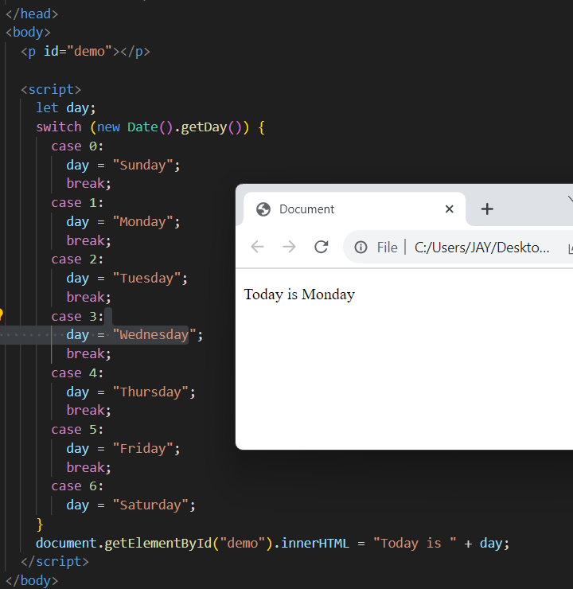

ii. Vowel or Consonant using switch case in JS?

Ans :

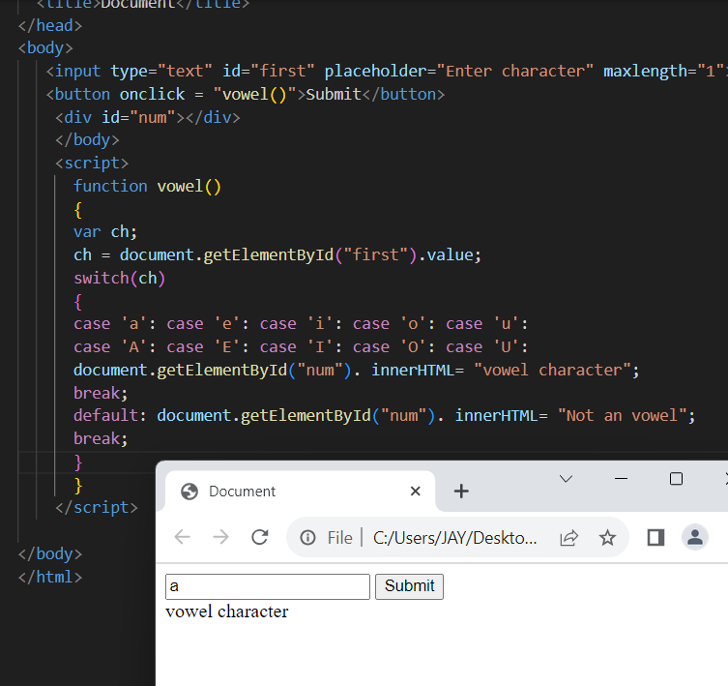

Q. What are the looping structures in JavaScript? Any one Example?

Ans : Loop is used to repeat a specific block of code a known number of times. There are 7 kind of loops you will find in JavaScript.

Ex :

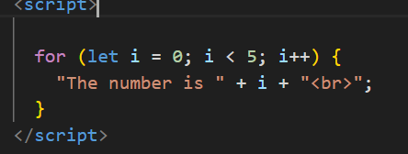

Q. Write a print 972 to 897 using for loop in JS?

Ans :

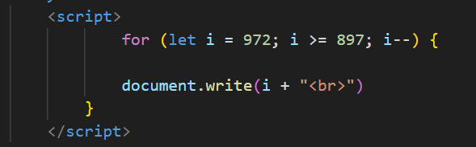

Q. Write to print factorial of given number?

Ans :

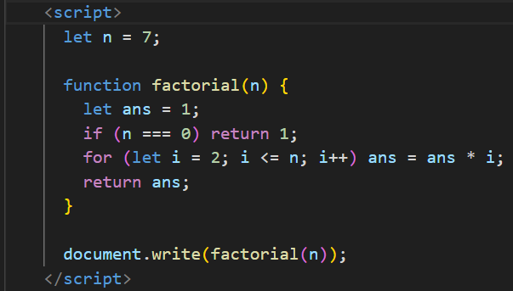output: 5040

Q. Write to print Fibonacci series up to given numbers?

Ans :

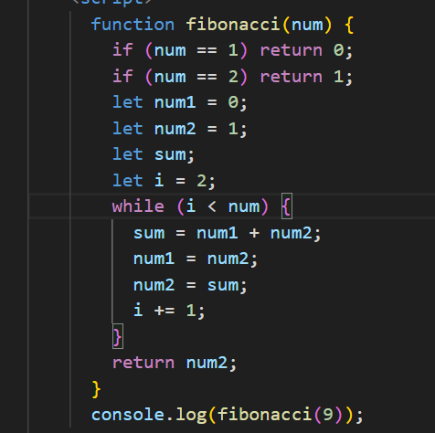

Q. Write to print number in reverse order e.g.: number = 64728 ---> reverse =82746 in JS?

Ans :

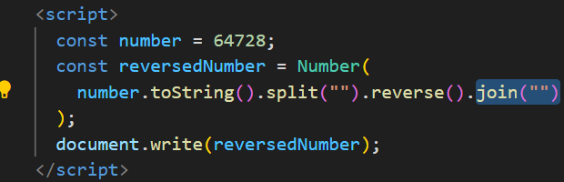

Q. Write a program make a summation of given number (E.g., 1523 Ans: - 11) in JS?

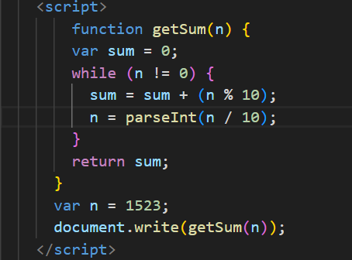Ans :

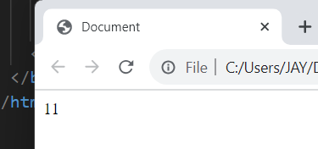

Q. Write a program you have to make a summation of first and last Digit. (E.g., 1234 Ans: -5) in JS?

Ans :

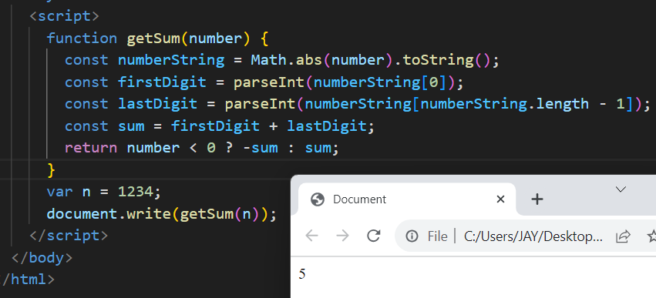

Q. Use console.log() and escape characters to print the following pattern in JS?

1 1 1 1 1

2 1 2 4 8

3 1 3 9 27

4 1 4 16 64

5 1 5 25 125

Ans :

 <script>

      for (let i = 1; i <= 5; i++) {

        let row = " ";

        for (let j = 0; j < 4; j++) {

          if (j === 0) {

            row += i + "";

          } else {

            row += Math.pow(i, j) + "";

          }

        }

        console.log(row.trim());

      }

    </script>

Q. Use pattern in console.log in JS?

1) 1

1 0

1 0 1

1 0 1 0

1 0 1 0 1

Ans :

   <script>

      for (let i = 1; i <= 5; i++) {

          let row = '';

          for (let j = 1; j <= i; j++) {

              row += (j % 2 === 1) ? '1 ' : '0 ';

          }

          console.log(row.trim());

      }

  </script>

2) A

B C

D E F

G H I J

K L M N O

Ans :

<script>

        let currentChar = 'A';

        for (let i = 1; i <= 5; i++) {

            let row = '';

            for (let j = 1; j <= i; j++) {

                row += currentChar + ' ';

                currentChar = String.fromCharCode(currentChar.charCodeAt(0) + 1);

            }

            console.log(row.trim());

        }

    </script>

3) 1

2 3

4 5 6

7 8 9 10

11 12 13 14 15

Ans :

<script>

      let n = 5;

      let string = "";

      let count = 1;

      for (let i = 1; i <= n; i++) {

        for (let j = 1; j <= i; j++) {

          string += count;

          count++;

        }

        string += "\n";

      }

      console.log(string);

4) *

* *

* * *

* * * *

* * * * *

Ans :

<script>

      let n = 5;

      for (let i = 1; i <= n; i++) {

        let str = "* ";

        console.log(str.repeat(i));

      }

    </script>

Q. Write a JavaScript Program to display the current day and time in the following format.

Sample Output: Today is Friday. Current Time is 12 PM: 12 : 22 2 ?

Ans :

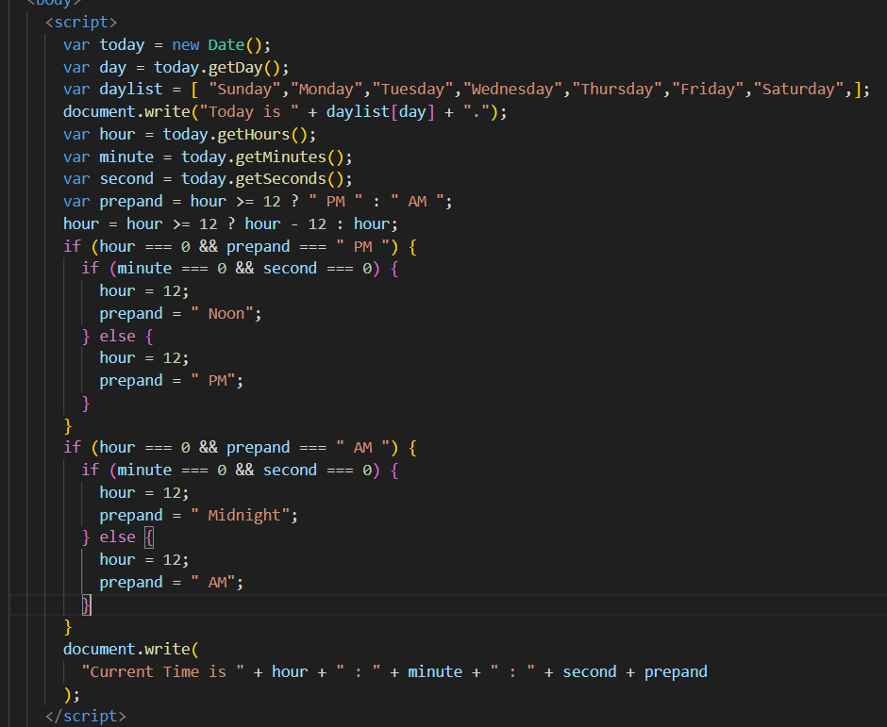

Q. Write a JavaScript program to get the current date?

Ans :

 <script>

      var date = new Date();

      var noe = date.getDate();

      document.write(noe);

    </script>

Q. Write a JavaScript program to compare two objects?

Ans :

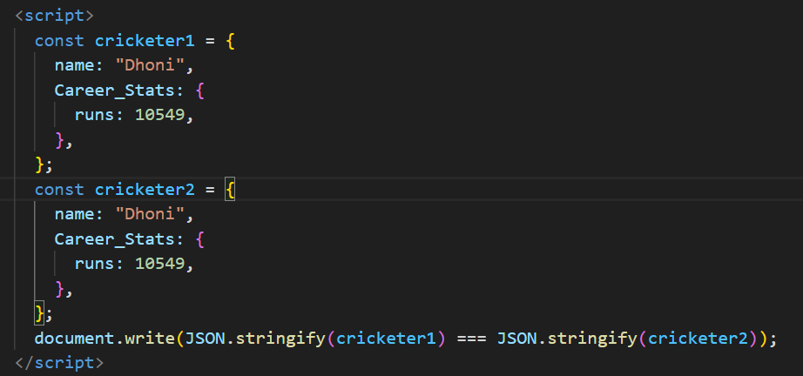

Q. Write a JavaScript program to convert an array of objects into CSV string?

Ans :

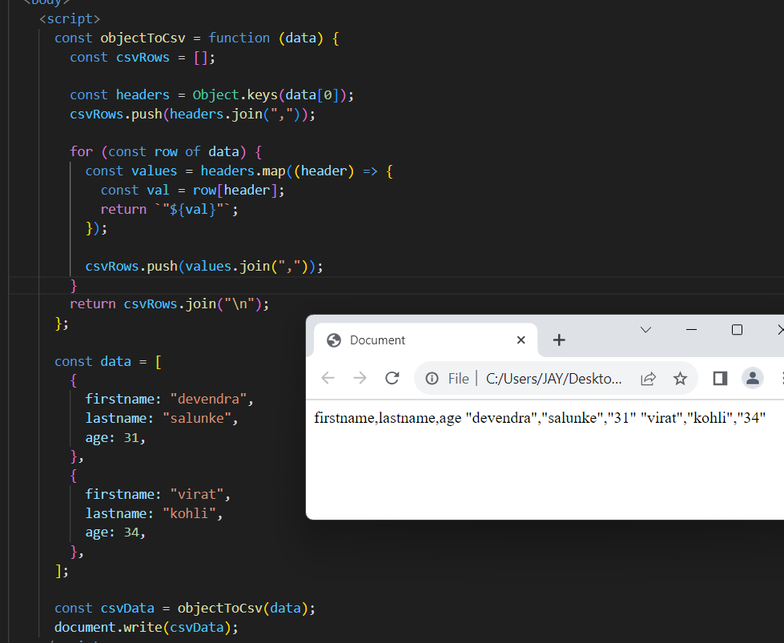

Q. Write a JavaScript program to capitalize first letter of a string?

Ans :

 <script>

      function capitalizeFirstLetter(str) {

        const capitalized = str.charAt(0).toUpperCase() + str.slice(1);

        return capitalized;

      }

      const string = "my name is jay.";

      const result = capitalizeFirstLetter(string);

      console.log(result);

    </script>

Q. Write a JavaScript program to determine if a variable is array?

Ans :

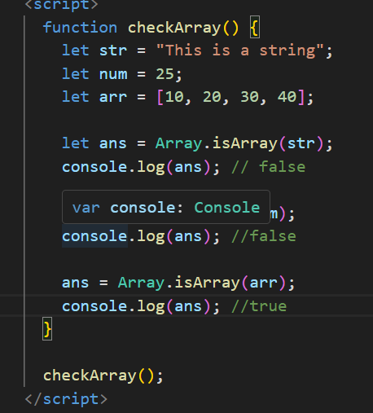

Q. Write a JavaScript program to clone an array?

Ans :

 const originalArray = [1, 2, 3];

      const clonedArray = [4,5,6].concat(originalArray);

      console.log(clonedArray);

Q. What is the drawback of declaring methods directly in JavaScript objects?

Ans : It creates a new instance of the function object for each instance of the object, which can affect memory efficiency.

It binds the scope of the constructor to each function, which can prevent garbage collection of the constructor arguments.

It makes the code less modular and reusable, as the methods are not shared on the prototype chain.

Q. Print the length of the string on the browser console using console.log()?

Ans :

<script>

      var myCountry = "india";

      console.log(myCountry.substring(0, 6));

    </script>

Q. Change all the string characters to capital letters using toUpperCase() method?

Ans :

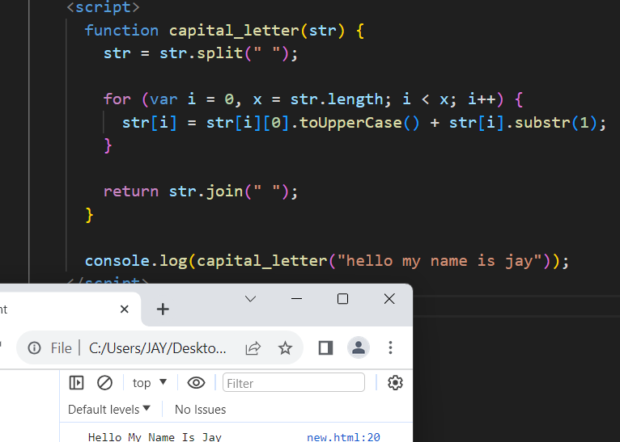

Q. Write a JavaScript program to get the current date. Expected Output : mm-dd-yyyy, mm/dd/yyyy or dd-mm-yyyy, dd/mm/yyyy?

Ans :

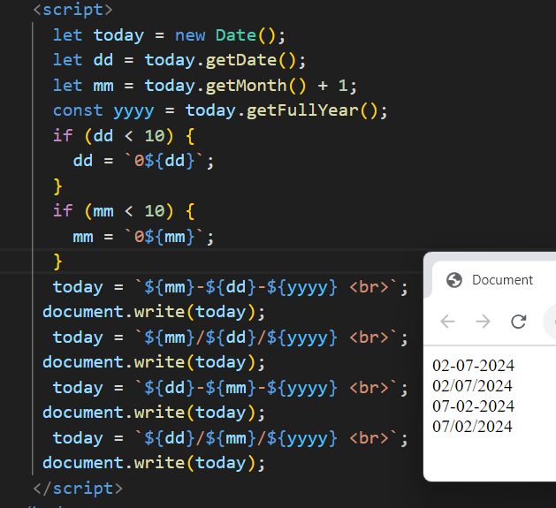

Q. Use indexOf to determine the position of the first occurrence of a in “30 Days Of JavaScript”?

Ans :

 let text = "30 Days Of JavaScript";

      let result = text.indexOf("a");

      console.log(result);// 4

Q. Use lastIndexOf to determine the position of the last occurrence of a in 30 Days Of JavaScript?

Ans :

 let text = "30 Days Of JavaScript";

      let result = text.indexOf("a");

      console.log(result);// 4

Q. how many type of JS Event? How to use it ?

Ans : The change in the state of an object is known as an **Event**. In html, there are various events which represents that some activity is performed by the user or by the browser. When [javascript](https://www.javatpoint.com/javascript-tutorial) code is included in [HTML](https://www.javatpoint.com/html-tutorial), js react over these events and allow the execution. This process of reacting over the events is called **Event Handling**. Thus, js handles the HTML events via **Event Handlers**.

Mouse events:

|  |  |  |
| --- | --- | --- |
| **Event Performed** | **Event Handler** | **Description** |
| click | onclick | When mouse click on an element |
| mouseover | onmouseover | When the cursor of the mouse comes over the element |
| mouseout | onmouseout | When the cursor of the mouse leaves an element |
| mousedown | onmousedown | When the mouse button is pressed over the element |
| mouseup | onmouseup | When the mouse button is released over the element |
| mousemove | onmousemove | When the mouse movement takes place. |

Keyboard events:

|  |  |  |
| --- | --- | --- |
| Keydown & Keyup | onkeydown & onkeyup | When the user press and then release the key |

Form events:

|  |  |  |
| --- | --- | --- |
| focus | onfocus | When the user focuses on an element |
| submit | onsubmit | When the user submits the form |
| blur | onblur | When the focus is away from a form element |
| change | onchange | When the user modifies or changes the value of a form element |

Q. What is Bom vs Dom in JS?

Ans : DOM

* The DOM represents the structure of a document as a tree of objects. Each object corresponds to a part of the document, such as elements, attributes, and text.
* Document: The top-level object that represents the entire HTML or XML document.
* Element: Represents HTML or XML elements in the document, like <div>, <p>, etc.
* Attribute: Represents attributes of elements, like id, class, etc.
* Text: Represents the actual text content within elements.

Bom

* The BOM represents the browser itself and provides objects and methods for interacting with the browser window and its components.
* Window: The top-level object that represents the browser window. It provides properties and methods for controlling the browser window
* Navigator: Provides information about the browser and its capabilities.
* Screen: Represents the user's screen and provides information like screen width and height.
* Location: Represents the URL of the current page.
* History: Represents the browser's session history.

Q. Array vs object defences in JS?

Ans : An array is an ordered, indexed collection of values. Each element in an array is identified by an index, starting from 0.

Arrays can hold values of any data type, including numbers, strings, objects, or even other arrays.

An object is an unordered, key-value pair collection of data. Each key (also called a property) is associated with a value.

Objects can hold values of any data type, and the keys are typically strings or symbols.

Q. Split the string into an array using split() Method?

Ans :

